unproductive. Despite this, Pareto efficiency is still an extremely useful concept.
It is a useful concept for two reasons:
- It can be an objective for an economy because it can set a direction towards which an economy can move.
- It can help highlight the imperfections and rigidities that exist in an economy and prevent Pareto efficiency being achieved.
Increasing opportunity cost
Opportunity cost can be thought of in terms of how decisions to increase the production of an extra, marginal, unit of one good leads to a decrease in the production of another good.
According to economic theory, successive increases in the production of one good will lead to an increasing sacrifice in terms of a reduction in the other good. For example, as an economy tries to increase the production of good X , such as cameras, it must sacrifice more of the other good, Y, such as mobile phones.
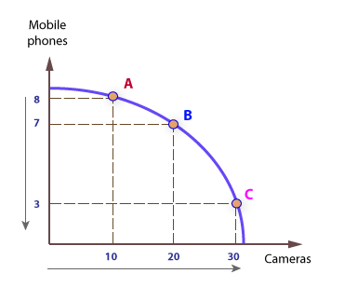
This explains why the PPF is concave to the origin, meaning its is bowed outwards. For example, if an economy initially produces at A, with 8m phones and 10m cameras (to 20m), and then increases output of cameras by 10m, it must sacrifice 1m phones, and it moves to point B.
If it now wishes to increase output of cameras by a further 10m (to 30m) it must sacrifice 2m phones, rather than 1m, and it moves to point C; hence, opportunity cost increases the more a good is produced.
The gradient of the PPF gets steeper as more cameras are produced, indicating a greater sacrifice in terms of mobile phones foregone.
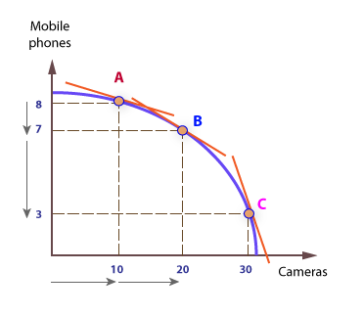

Full employment:
State of economy in which all eligible people who want to work can find employment at prevailing wage rates. However, it does not imply 100 percent employment because allowances must be made for frictional unemployment and seasonal factors.:

The first definition of full employment would be the situation where everyone willing to work at the going wage rate is able to get a job.
This would imply that unemployment is zero because if you are not willing to work then you should not be counted as unemployed. To be classified as unemployed you would need to be actively seeking work. This does not mean everyone of working age is in employment. Some adults may leave the labour force, for example, women looking after children.
But, in practise, we never see 0% unemployment, and this can make full employment hard to define. Generally, unemployment rate of 3% or less would be considered to be full employment. But, this is a figure the UK hasn’t experienced for many decades.
Optimal Unemployment Level
Another definition of full employment would be the ‘optimal’ level of unemployment. In practise, an economy will never have zero unemployment because there is inevitably some frictional unemployment. This is the unemployment where people take time to find the best job for them. Frictional unemployment is not necessarily a bad thing. It is better people take time to find a job suitable for their skill level, rather than get the first job that comes along. Generally, you may expect frictional unemployment to cause an unemployment rate of 2-3%. Therefore, some economists may claim that unemployment of less than 3% indicates ‘full employment’ – or at least very close.

Cyclical Unemployment
Over time, the economy experiences many ups and downs. That's what we call cyclical unemployment because it goes in cycles. Cyclical unemployment occurs because of these cycles. When the economy enters a recession, many of the jobs lost are considered cyclical unemployment.
For example, during the Great Depression, the unemployment rate surged as high as 25%. That means one out of four people were willing and able to work, but could not find work! Most of this unemployment was considered cyclical unemployment. Eventually, unemployment came down again. As you can see, at least part of unemployment can be explained by looking at the cycles, or the ups and downs of the economy.
Frictional Unemployment
Frictional unemployment occurs because of the normal turnover in the labor market and the time it takes for workers to find new jobs. Throughout the course of the year in the labor market, some workers change jobs. When they do, it takes time to match up potential employees with new employers. Even if there are enough workers to satisfy every job opening, it takes time for workers to learn about these new job opportunities, and for them to be considered, interviewed and hired.
When Cindy graduates from college, she begins looking for work. Let's say it takes her four months to land a new job. During this time, she is frictionally unemployed.
Structural Unemployment
Let's talk about structural unemployment occurs because of an absence of demand for a certain type of worker. This typically happens when there are mismatches between the skills employers want and the skills workers have. Major advances in technology, as well as finding lower costs of labor overseas, lead to this type of unemployment.

Lesson 4

8- economic wants and resources :
The want is the personal feeling and desire to obtaining economic commodities .
Economic wants have four qualities:-
a/ The ability of satisfaction.
b/ The ability of renew ability.
c/ Multiplicity .
d/ The ability of replacement.

Resources are all materials and goods obtained or produced by people and available in the economy:-(food, clothes, machines, buildings , lands, waters, money….etc.

9- the commodity and utility:-
The commodity is a concept refers to everything that satisfies the human need.
Utility is the ability of the commodity on satisfying the human wants.
10- The price and value :-
The price is the quantity of money paid to get a good or service.
The value is the quantity of money spend in producing or manufacturing the economic commodity .

Value = All costs paid in producing the commodity.

